Requirement Document Contents

1.0.0 Introduction and Summary 2

2.0.0 Hardware and Software Requirements and Limitations 3

3.0.0 Entity Relationship Diagram 4

4.0.0 Functional Requirements 5

4.1.0 Student Data Requirement 5

4.2.0 Database Requirement 5

5.0.0 Non-Functional Requirement 8

6.0.0 User/Audience 9

7.0.0 Risk Assessment 10

8.0.0 Work Breakdown 11

# 1.0.0 Introduction and Summary

The Convocation Program at Lenoir Rhyne University requires a database to store and manipulate its current program information about students and convocation categories. The program also has a need for a graphical user interface that allows access to two kinds of user’s: Administrative and Student Worker. For security reasons users must enter a set of credentials in order to access and manipulate any type of data and information available on the database. Functionality includes the ability to generate several types of reports that range from showing the percentage of convocations attended by the student body to whether or not a full time student meets the criteria of the convocation program. Another important function that the program requires is for the ability to transfer an excel spreadsheet into the database and visa versa.

Team Strata’s requirements document describes what the project contains. The document includes software and hardware constraints, an entity relationship diagram, functional and non-functional requirements, and a risk assessment table.

The software and hardware constraints describe the minimum hardware and software requirements that need to be on a computer in order to run the database properly. The entity relationship diagram (ERD) provides the end user a view of the tables and attributes that are included in the database while the functional and non-functional requirements provide more insight to the ERD. Lastly, the risk assessment table provides an oversight for the possible risks that may be encountered before and after the project’s completion.

# 2.0.0 Hardware and Software Requirements and Limitations

Team Strata Corporations database requires certain hardware and software so that computers running the database have proper functionality. Windows XP is the operating system best fit for the database although operating systems Windows Vista and Windows 7 work as well. A computer that is equipped with an Intel [R] Core [TM] 2 CPU and running at a 4300 @1.80 GHz or 1.79 GHz with a minimal of 1 GB of RAM and memory allows for the database to run at its fullest potential.

The software requirements are listed as follows for documentation and creation of the database: Microsoft Word 2007, Microsoft Visio 2007, and Microsoft Access 2007.

The Front- End for the GUI is built in Microsoft Visual 2010 and uses the programming language Visual Basic.

# 3.0.0 Entity Relationship Diagram

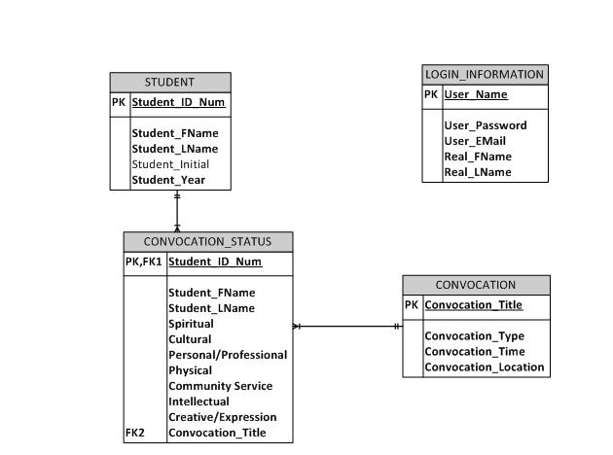  
**Figure 3.0.1**

# 4.0.0 Functional Requirements

**4.1.0 Student Data Requirement**

4.1.1 A student must possess a personal identification number.

4.1.2 A student must be classified as a full-time day student to be required to attend convocations.

4.1.3 A student must completely fill out a “convocation card” in order for that data to be entered into the system, which allows for student credit.

## 4.2.0 Database Requirement

4.2.1. All registered users of the program shall be classified into one of the following groups: Administrators, Faculty Users, or Student Workers.

4.2.2. Non-Registered users of the program shall only be able to view the “front- end” of the Graphical User Interface, as they shall not possess valid log in identification.

4.2.3. An administrator role may view each and every piece/part of the database system, these including, but not limited to, the source code of the Graphical User Interface (G.U.I), the student records which are to be stored within the database, and all tables and/or entities created in the database system.

4.2.4. Any data manipulation, including, but not limited to, deleting or adding of students into the database system, changing of existing student information such as convocations completed and/or needed, or changing of the status of any given student to indicate said student has now completed a convocation of any given type, shall be performed by the faculty member who maintains the database and student convocation information.

4.2.5. The user name of any registered user shall be resigned to the last and first name of the user separated by a single period, for example, Doe.John, would be the user name for a user with the name John Doe.

4.2.6. The password of any individual user shall be limited to no less than six characters and no more than fifteen characters. Characters allowed in passwords include lower-case letters, upper-case letters, numbers, and special characters. Spaces shall not be permitted within a password.

4.2.7. A user must correctly enter his or her user name and password and be verified within the system in order to view and manipulate data within the system, including personal student information and completed convocation status.

4.2.8. A user with the appropriate clearance of Faculty shall be able to generate and print reports on student information and convocation status.

4.2.9. Reports shall be used to view student information such as, but not limited to, the student's name, identification number, and the number and types of convocations said student attends over the course of the year.

4.3.1. Data entered into Microsoft Excel regarding student information and/or convocation status shall be exported to Microsoft Access in order to place said information into an easier to read and easier to use table format, and so that data concerning convocation status can be more easily manipulated.

4.3.2. Tables in the database system include STUDENT, CONVOCATION, CONVOCATION_STATUS, and LOGIN_INFORMATION.

4.3.3. The STUDENT table includes the following attributes: Student_ID_Num, Student_FName, Student_LName, Student_Initial, and Student_Year.

4.3.4. The CONVOCATION table includes the following attributes: CONVOCATION_TITLE, CONVOCATION_TYPE, CONVOCATION_TIME, and CONVOCATION_LOCATION.

4.3.5. The CONVOCATION_STATUS table includes the following attributes: Student_ID_Num, Student_FName, Student_LName, Spiritual, Cultural, Physical, Personal/Professional, Community Service, Creative/Expression, and Intellectual.

4.3.6. The LOGIN_INFORMATION table includes the following attributes: User_Name, and User_Password.

**5.0.0 Non-Functional Requirement**

5.0.1. The Graphical User Interface shall be simple to navigate so that any user may easily navigate to the information within the database system.

5.0.2. Data regarding multiple students' convocation statuses may be searched for and changed easily with queries and entry commands. For example, faculty shall be able to quickly and efficiently search certain students or classes in order to ascertain as to who has completed convocation requirements.

5.0.3. Student information such as name, identification number, and class, shall be more readily available to searching faculty.

5.0.4 How fast the database proceeds to retrieve data is based on the user’s computer. If the computer does not meet the minimum software constraints then the database runs slower and performance decreases.

**6.0.0 User/Audience**

There are two types of user for this project: student worker, administrator. Student worker is a student volunteer who inputs general information about a specific convocation and inputs which students attend which convocation program. The Student Worker accounts do not have access to personal student information kept in the tables nor will they be able to alter them.

The administrative user is a specific faculty member that has administrative authority over the database. The Administrator has the ability to access and scan the database for any errors made by the Student Worker account. Also, the Administrator changes or updates existing data to make the data more efficient and the database hold constant, up-to-date information for the convocation program.

The intended audience of this database project is the faculty/staff and student body of Lenoir-Rhyne University. This project aims to help them with the task of keeping convocation and student attendance information so that there is little to no error in the convocation program.

# 7.0.0 Risk Assessment

The following information contains a risk assessment table for Strata Corporation’s Convocation database project. The table takes into account of the risks one may encounter in the future. The risks fall into one of three types: security, hardware/software, and human error and are rated on a scale of one to three, three being the highest.

|  |  |  |  |  |
| --- | --- | --- | --- | --- |
| **Risk type** | **Risk** | **Risk rating** | **Explanation** | **Avoidance strategy** |
| Security | Information seen by wrong people | 3 | If permissions are not set correctly during the creation of the database, users may have access to data extraneous to their job. | Careful monitoring of permissions. |
|  | Data stolen | 2 | If information is seen by someone with malicious intent, private information may be used. | Careful monitoring of permissions and staff. |
|  | Hacked | 1 | The database is accessed by another party not meant to view it. | Always make sure one logs off after using the database. |
| Hardware/software | Data loss | 1 | Uses keystrokes instead of manually saving. | Do not manually save. |
|  | System requirements not met | 1 | The database will not function properly; information will not be accessible if the Microsoft Access is not installed, or if there is not enough memory available, he database will run slowly. | See system requirements. |
| Human error | Rollback-related issues | 1 | As the Strata group is made up of students, there may be some setbacks in the creation of the database if “rollback” is used incorrectly. This will only really affect the timeline. | Documentation and careful attention to detail. |
|  | Commit issues | 2 | When using the final database, the client MUST remember to commit the information already entered occasionally, or the data will be lost. | Automated reminder. |

# 8.0.0 Work Breakdown

Stacey Brown – Introduction and Summary, planned ERD, Functional and Non-functional requirements.

Cameron Chandler – User/Audience

Brandon Harwood – Functional requirements, Non-functional Requirments, planned ERD.

Alfred McCorkle – Software and Hardware constraints.

Darin Philyaw – Functional Requirements, Non-Functional Requirements, produced and planned ERD.

Kelsey Willett – Risk Assessment